**User Manual: How to Apply for a Position**

This guide will walk you through the process of applying for a position using the company portal. Follow the steps carefully, and refer to the accompanying images for assistance.

**1. Visit the Website**

* Navigate to the company’s official website.
* Locate and click on the **Portal** option from the homepage.

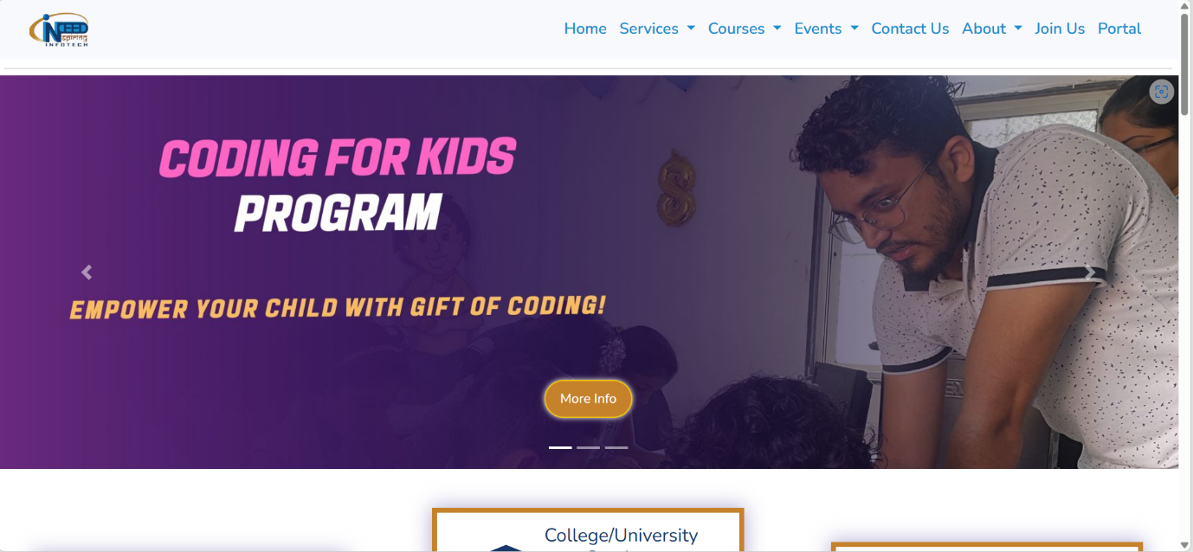

**2. Enter Your Email**

* On the portal page, enter your **email address** in the designated field.
* Click the **SEND OTP** button to proceed.

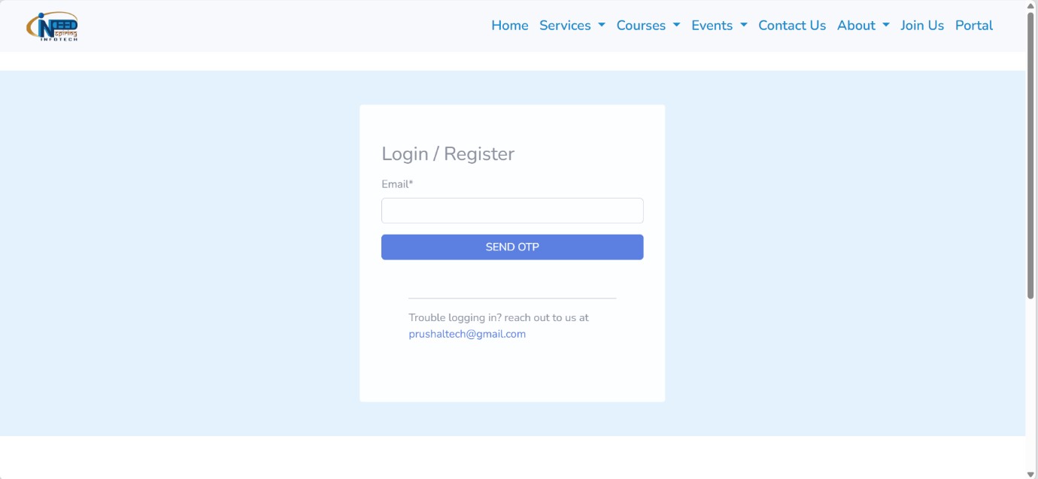

**3. Verify OTP**

* An OTP (One-Time Password) will be sent to the provided email address.
* Check your inbox, retrieve the OTP, and enter it in the verification field.
* Click **SUBMIT** to complete the authentication process.

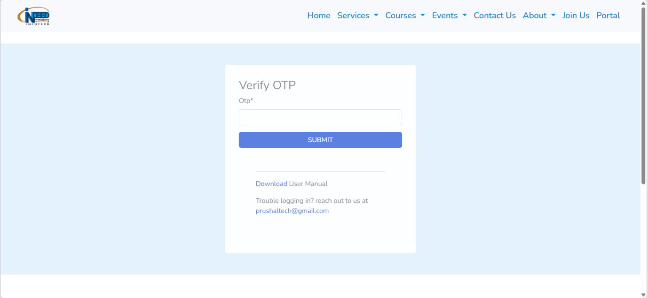

**4. Access the Dashboard**

* After successful OTP verification, you will be redirected to your **dashboard**.
* Here, you can access various features of the portal.

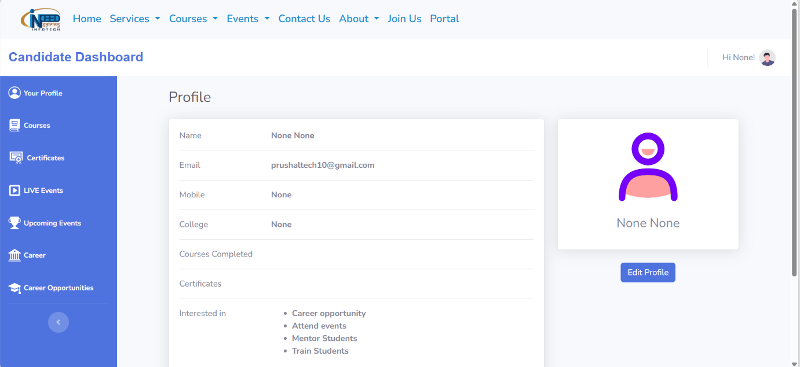



**5. Edit Profile and Upload Resume**

* In the dashboard, click on the **Edit Profile** option.
* Update your personal details as needed.
* **Upload your resume** (mandatory) by selecting the file from your device.
* Ensure your resume is successfully uploaded before proceeding.
* Click **Update Profile** button to proceed.

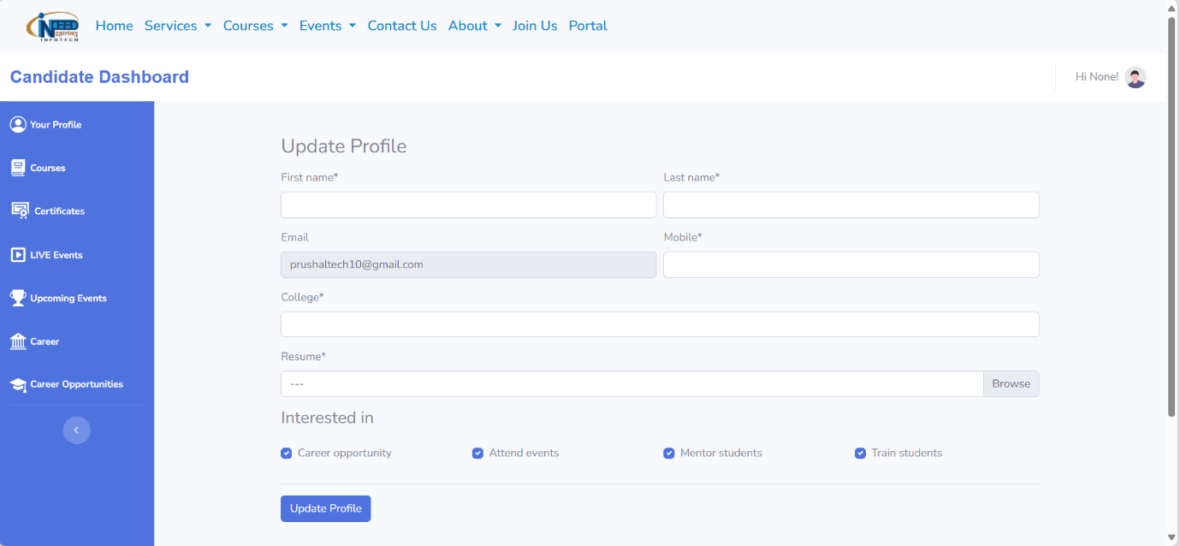



**6. Navigate to Career Opportunities**

* Click on the **Career Opportunities** section.
* Here, you will find a list of available job openings.

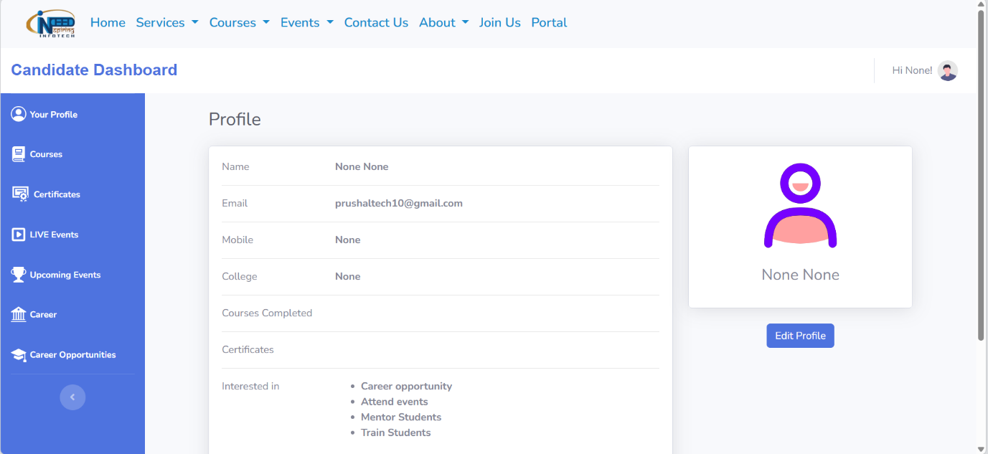



**7. Review Job Listings**

* Each job listing will display details such as job title, description, and requirements.
* Under the **Document** column, click the **Download** button to view the Job Description (JD).

**8. Apply for a Job**

* In the same job listing table, locate the **Apply** button in the last column for the desired job.
* Click the **Apply** button to submit your application.

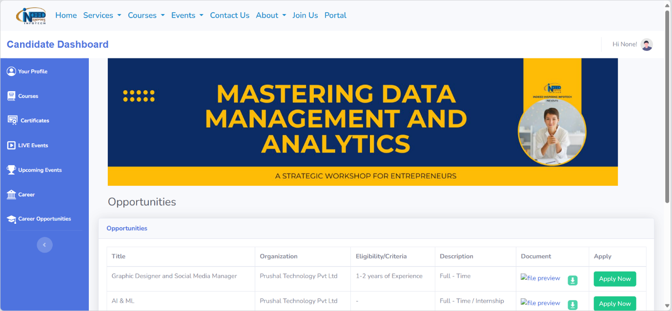

**9. Confirmation**

* Once you click **Apply**, your application will be successfully submitted.
* You may receive a confirmation message regarding your application status.

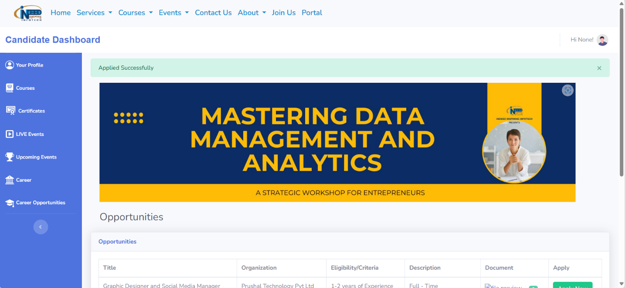

**Important Notes**

1. Ensure all mandatory fields in your profile are filled before applying.
2. Double-check the uploaded resume for accuracy and relevance.
3. Review the Job Description (JD) carefully before submitting your application.

By following these steps, you can efficiently apply for job opportunities through the portal.